**How to Apply for Scholarships within Scholarship Universe**

(Recommended) File your Free Application for Federal Student Aid (FAFSA) before you get started on Scholarship Universe. Many scholarships within your department, college(s) and UArizona require a FAFSA to even be considered for scholarship awards. We strongly recommend you submit a FAFSA if you are eligible to do so. This must be done every year. For more information on the FAFSA, visit the Department of Education’s website: <https://fafsa.gov>

* Log in to [Scholarship Universe](https://financialaid.arizona.edu/scholarshipuniverse) (SU) with your UA Net ID and Password.
* Click on QUESTIONS in the left-hand navigation bar, then click on Answer More Questions

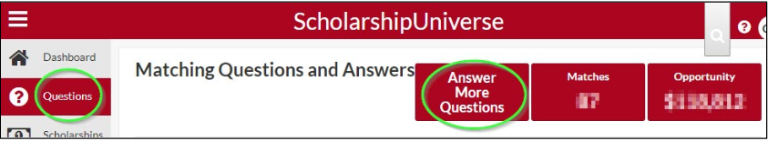

**OR-** Click on the gray text box (shown below) to answer all the outstanding questions for your student profile. The answers to these questions will match you to internal and external scholarships.

* **If you’ve never created a profile before:**

This step may take up to one hour, until you have no more questions to answer. This step is vital to match you with as many scholarships as possible and maximize the potential for funding. Answer as many matching questions as possible, until you are no longer presented with any new questions.

* **If you have previously created a profile:**

Your answers need to be updated/edited each academic year or as they change. If you changed majors, new clubs, activities, academic level, etc.

To edit an answer, click the pencil icon (right side of the question) and update.

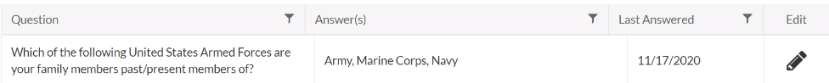

* **Once you are done, you are ready to apply by clicking SCHOLARSHIPS in the left-hand navigation bar.**

Click APPLY and answer the required questions and/or upload all the required items to each application scholarship you would like to apply for. Your application will not be complete until all the required items are submitted.

***If an application requires a Letter of Recommendation (LOR), please complete this step immediately****.*

You must send an email request through the SU scholarship application to the individual from whom you are requesting the LOR. (See below for best practices.)



