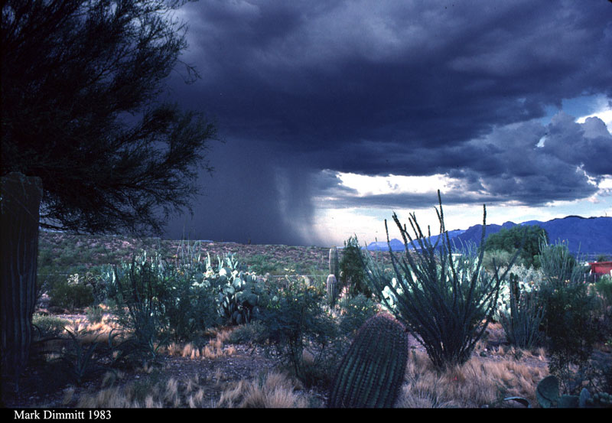

ATMO 170A
&
ATMO 336
Photo Arizona-Sonora Desert Museum
Work at home this summer!
Complete a course online in 4 weeks!

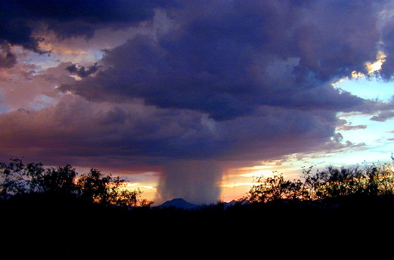
Meet the winds of the world

Monsoon, typhoon, hurricane, cyclone, tornado, waterspout, and dust devil

…and other star attractions

El Niño, global warming, ozone depletion, air pollution, impact of weather and climate on individuals and society, and vice versa

ATMO 170A Introduction to Weather and Climate
- Fulfills Gen Ed Tier 1 Natural Science
- Sec 101 meets June 6-July 7, 2016 & Sec 102 meets July 11-August 10, 2016

ATMO 336 Weather, Climate, and Society
- Fulfills Gen Ed Tier 2 Natural Science
- Meets July 11-August 10, 2016
- Basic weather phenomena, climate and climate change, and associated effects on individuals and societies in the past and present, including the possibility and effects of human-caused changes in the climate system

